

#### MULTIVENDOR MUSICIAN PLATFORM CONSULTATION PROPOSAL

##### Design, Build & Scale

**Client Info:**

**Name: <<Client Name>>**

**Email: <<Client Email>>**

**Phone: <<Client Number>>**

**Country: <<Country>>**

**Date: <<Date>>**

+12088421478

[info@appsynergies.com](mailto:info@appsynergies.com)

186 Malvern Avenue, Harrow, HA2 9HD, UK AppSynergies Pvt Ltd, D-1602, Orchid Suburbia, Link Road, Kandivali West, Mumbai 400067, India

2

 [www.appsynergies.com](http://www.appsynergies.com/)

Table of Contents

* Company Overview 3
* Our Services 4
* Our Approach 6
* Team Expertise 7
* Business Requirements & Project Overview 8
* Project Pricing 12
* Project Timeline 14
* Client Onboarding 15
* Terms & Conditions 16
* Client Testimonials 17
* Case Studies 18
* Contact Us 20

[info@appsynergies.com](mailto:info@appsynergies.com)

+12088421478

3

 [www.appsynergies.com](http://www.appsynergies.com/)

## COMPANY OVERVIEW



Why Us?

   

|  |  |  |  |  |  |
| --- | --- | --- | --- | --- | --- |
| **100+** | **50+** | **50+** | **100+** | **50+** | **10+** |
| **Projects** | **Apps** | **Websites** | **Happy** | **Technical** | **Years** |
| **Completed** | **Developed** | **Developed** | **Clients** | **Team** | **Experience** |

About Us

Driving Growth Through Technology and Marketing. We help businesses thrive in the digital landscape. From crafting innovative AI-driven apps and websites to executing high-impact SEO, ASO, SMM, content, and email marketing strategies, we deliver measurable results that matter.

We are a fast-growing business with a very talented and rapidly expanding team. We specialize in Design, Development, Testing, Release & Project Management of AI driven apps & websites. We also specialize in Digital Marketing Services like SEO, ASO, SMM, Content & Email Marketing.

Mission

To be a part of people's daily lives by helping them build lasting relationships in an environment of trust & respect.

Vision

To be one of the leading technology & marketing companies in the world, admired for its innovative products & services thereby contributing to a better & sustainable world.

[info@appsynergies.com](mailto:info@appsynergies.com)

+12088421478

4

 [www.appsynergies.com](http://www.appsynergies.com/)

## OUR SERVICES

App Design & Development

At AppSynergies, we build well-designed and optimized custom mobile applications with a delightful UX for both iOS and Android.

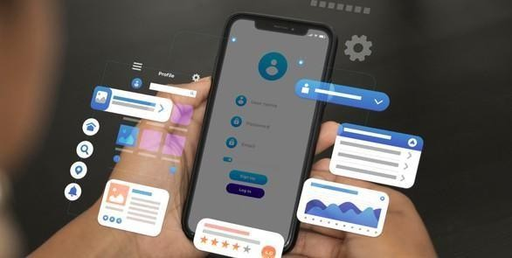 iOS Android

Flutter



 React JS

 Firebase

AI Automations

At AppSynergies, we help you to transform your business with AI & drive growth. Automate repetitive tasks, boost productivity, and make smarter decisions with our powerful AI solutions!

 AI Calling  Chatbots

Make Automations

GHL

Automations

 ManyChat Automations

[info@appsynergies.com](mailto:info@appsynergies.com)

+12088421478

5

 [www.appsynergies.com](http://www.appsynergies.com/)

Website Design & Development

At AppSynergies, we offer a complete range of website services that build up business value, from the initial idea and formulation of product strategy, through building a prototype and testing it with users, right to the creation of the product itself.



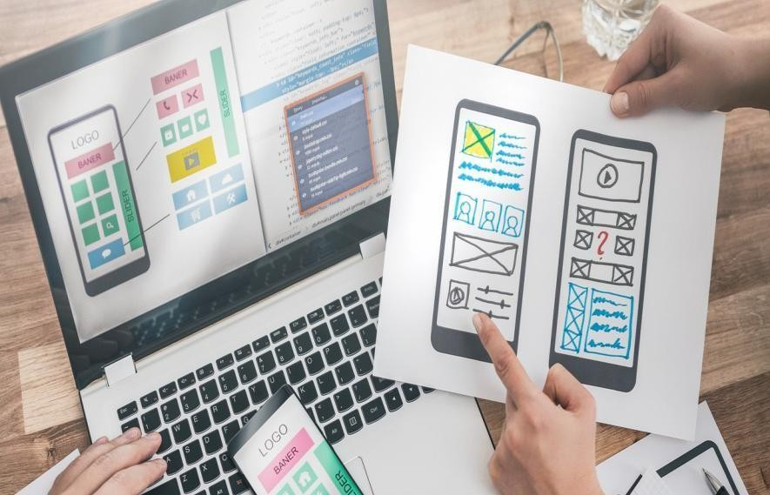Digital Marketing



Custom Website Design

E-Commerce Development

Responsive Web Design

Content Management System (CMS)

Web Maintenance & Support



We are an AI driven digital marketing agency empowering your business to innovate, optimize & grow in your market using AI-fueled marketing strategies. Our team of experts has over 5 years of experience in the digital marketing industry.

SEO

Social Media Marketing

Content Marketing



 PPC Advertising  Email Marketing

Influencer Marketing

Manual & AI Sales Service



[info@appsynergies.com](mailto:info@appsynergies.com)

+12088421478

6

 [www.appsynergies.com](http://www.appsynergies.com/)

## OUR APPROACH

###### Technical Services

* We begin by researching your industry and audience to create a tailored strategy.
* Our creative team crafts visually stunning and user-friendly apps and websites.
* We offer a complete range of technical services that build up business value.

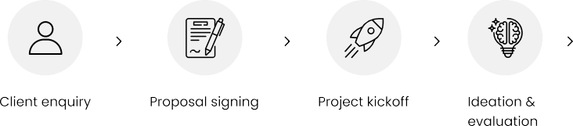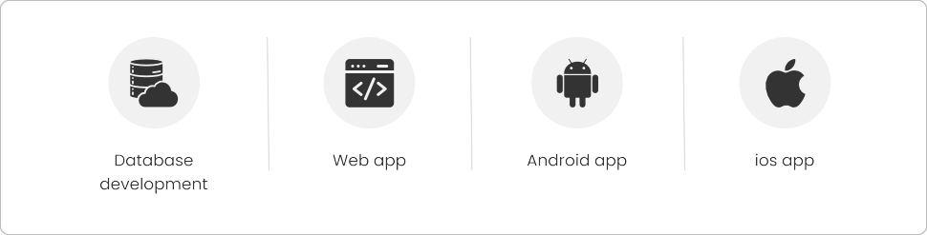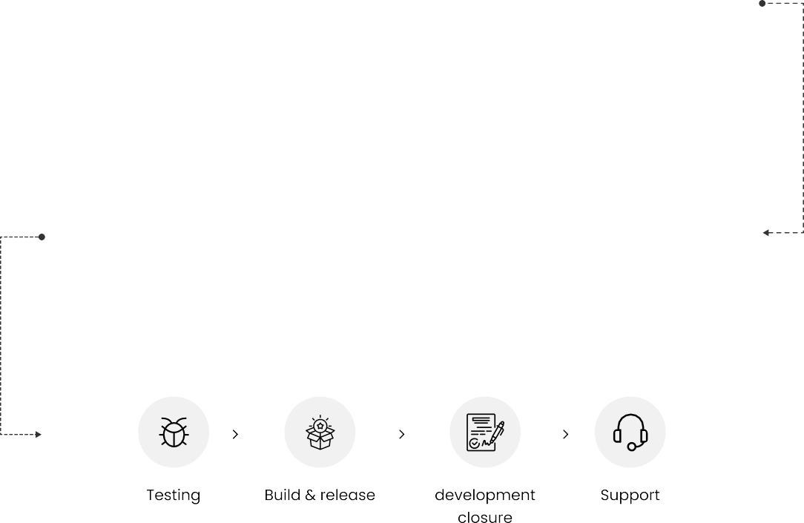

[info@appsynergies.com](mailto:info@appsynergies.com)

+12088421478

7

 [www.appsynergies.com](http://www.appsynergies.com/)

## TEAM EXPERTISE



Our team comprises of experts in various technical & marketing fields with approximately 5 - 10 years of experience & knowledge in delivering complex projects.

You will have the below list of experienced professionals working on your project:

* Project Manager: <<P1>>
* Business Analyst: <<P1>>
* UI/UX Members: <<P1>>
* Backend Developers: <<BD1>>
* Frontend Developers: <<P1>>
* AI/ML Developers: <<P1>>
* System Architect: <<P1>>
* AWS Developer: <<P1>>



[info@appsynergies.com](mailto:info@appsynergies.com)

+12088421478

8

 [www.appsynergies.com](http://www.appsynergies.com/)

Business Requirement & Project Overview



**User Registration and Verification**

1. **User Registration:** Musicians, event organizers, and customers can register on the platform using an email, phone number, or social media accounts.
2. **User Profile Creation:** Users can create profiles with personal details, event requirements, and location information.
3. **Musician Registration:** Musicians can create profiles showcasing their expertise, instruments played, genres, availability, and pricing.
4. **Event Organizer Registration:** Event organizers can register by listing their event types, requirements, and budget for hiring musicians.
5. **Location-Based Registration:** Registration includes location data to match event organizers with musicians in their vicinity.
6. **Adjustable Geographical Radius**: Musicians can modify their availability radius based on their schedule and willingness to travel.
7. **KYC Verification for Musicians:** Musicians must submit identity verification documents before being approved.
8. **Role-Based Access Control:** Different roles (customer, musician, event organizer) are assigned specific access rights within the platform.
9. **Phone Number Verification:** Users and musicians must verify their phone numbers via OTP to ensure authenticity.
10. **Email Verification:** A confirmation email is sent to verify the provided email address during registration.

[info@appsynergies.com](mailto:info@appsynergies.com)

+12088421478

9

[www.appsynergies.com](http://www.appsynergies.com/)

1. **Two-Factor Authentication:** An optional security feature allowing users to secure their accounts.
2. **Profile Approval Process:** Musician profiles undergo an admin approval process after KYC verification.
3. **Background Check for Musicians:** For enhanced trust, background checks are conducted on musicians during KYC verification.
4. **Admin Role in Registration:** Admins can approve or reject musician and event organizer registrations based on documentation.
5. **User Consent Management:** All users must consent to the platform’s terms and conditions before completing registration.
6. **User Data Privacy:** The platform ensures compliance with data protection regulations to safeguard users' personal information.
7. **Notifications on Registration Status:** Users receive real-time updates on the status of their registration and verification process.
8. **Profile Update Mechanism:** Registered users can update their personal details, services, and location information post-registration.
9. **User Role Changes:** Customers can switch roles to become musicians or event organizers after completing the registration and verification processes.
10. **Verification Reminders:** Musicians receive automated reminders to complete their KYC and verification steps if pending.

**Modular Architecture**

1. **User Management Module:** Handles user registrations, profiles, and KYC verification for musicians and event organizers.
2. **Gig Posting Module:** Allows event organizers to post event requirements for different music genres and performance types.
3. **Musician Notification Module:** Notifies musicians about relevant gig opportunities based on location and genre preference.
4. **Lead Management Module:** Uses a credit/coin system to manage and respond to gig requests efficiently.
5. **Rating and Review Module:** Collects ratings and reviews from event organizers for musicians and vice versa, ensuring transparency.
6. **Responsive Design Module:** Ensures the platform is mobile-friendly and accessible across devices.
7. **Admin Dashboard Module:** Allows administrators to manage user registrations, KYC verifications, and platform analytics.
8. **Multi-Genre Support Module:** Facilitates multiple music categories, supporting a diverse range of musical styles.

[info@appsynergies.com](mailto:info@appsynergies.com)

+12088421478

10

[www.appsynergies.com](http://www.appsynergies.com/)

1. **Scalability Module:** Designed for future enhancements, ensuring the platform can grow with new features and users.

**Admin Panel**

1. **Platform Monitoring:** Admin can track platform performance and analytics.
2. **Content Management:** Admin manages content such as event categories, musician profiles, and promotional banners.
3. **Lead Management:** Admin oversees lead distribution and escalated queries.
4. **Payment and Billing Management:** Admin handles subscription billing and payment processing.
5. **Discount and Offer Management:** Admin manages discounts and offers from equipment providers.
6. **Notification Management:** Admin configures notification settings for users and musicians.
7. **Dispute Resolution:** Admin resolves disputes between event organizers and musicians, ensuring fair practices.
8. **Analytics and Reporting:** Admin generates reports on user activity, musician performance, and financial transactions.
9. **User and Musician Banning:** Admin has the authority to suspend or ban users and musicians violating platform policies.
10. **Security Management:** Admin ensures platform security through regular audits, data encryption, and compliance with regulations.

**In-App Features**

1. **Gig Request Posting:** Event organizers can post gig requests based on musical genres and performance types.
2. **Instant Musician Notifications:** Musicians receive real-time notifications about relevant gig postings.
3. **Dual Role Capability:** Users can be both musicians and event organizers, allowing flexibility in bookings.
4. **Customer Section for Venue Discovery**: Normal users can browse feeds to see which cafe/bar/pub has available musicians based on their area.
5. **KYC Verification:** Musicians must submit KYC details before accepting bookings.
6. **Escrow-Based Payment System**: 20% of the total payment is collected at the time of booking and held in an escrow account. If the musician accepts, the amount is debited; otherwise, it is refunded.
7. **Instant Chat Feature**: Once a booking is confirmed, a dedicated chat is created between the venue owner and the musician to facilitate communication.

[info@appsynergies.com](mailto:info@appsynergies.com)

+12088421478

11

[www.appsynergies.com](http://www.appsynergies.com/)

1. **Discount Offers:** Equipment providers can offer discounts on rental services for musical instruments.
2. **Lead Management System:** Musicians use a credit or coin-based system to respond to gig leads efficiently.
3. **Rating and Review System:** Event organizers can rate and review musicians based on their performance.

**Integrations**

1. **Payment Gateway Integration:** Supports secure transactions for subscriptions, musician payments, and equipment rentals.
2. **KYC Integration:** Ensures verification of musician and event organizer identities.
3. **Location-Based Notification System:** Notifies musicians about gig requests based on their proximity.

**Scalability and Security**

1. **Secure Transactions:** Uses encrypted communication and payment processing for security.
2. **Scalable Infrastructure:** Designed to handle growth, allowing expansion into new markets and additional music services.
3. **Data Privacy Compliance:** Ensures compliance with data protection regulations for user privacy.

Note:

In the initial phase we would be designing & prototyping the website/app/admin panel to show a demo of how it the flow will be and with the click of each button, what will be the situations that we would have to handle to ensure ease of use of the platform.

The points mentioned will be taken care of, feedback from the client will be our priority and depending of the feedback, situations & use cases, these features might be changed accordingly.

[info@appsynergies.com](mailto:info@appsynergies.com)

+12088421478

12



 [www.appsynergies.com](http://www.appsynergies.com/)

## PROJECT PRICING

**Design ₹ 1,50,000**

**Development ₹ 3,50,000**

**AI/ML Models ₹ NA**

**Total Cost ₹ 5,00,000 + 18% GST**

**Annual Maintenance ₹ 35,000**

This annual maintenance fee covers the charges to make sure the platform is live and always running properly. If there are any live bugs or anything goes wrong with the platform then we will make sure it is fixed and deployed as soon as possible. We also regularly check & run tests on the platform to make sure everything is working fine.

**Additional Features**

**& Enhancements ₹ 25,000**

We would be charging this amount for a team (1 BA/PM, 1 UX, 1 Dev, 1 QA) per week (5 days/40 hrs) on project work after the project completion for any ongoing enhancements, features that the client would want after release.

[info@appsynergies.com](mailto:info@appsynergies.com)

+12088421478

13

 [www.appsynergies.com](http://www.appsynergies.com/)

###### Payment Method

**AppSynergies Pvt Ltd accepts the following payment method:**

* Bank Transfer
* Credit Cards and Debit Cards
* Net Banking
* Gpay or Paytm

###### Payment Schedule

|  |  |
| --- | --- |
| **Sr No.** | **Schedule** |
| 1 | Before starting the project, the client needs to pay 30% of the total or the estimated amount. |
| 2 | On 50% project completion, the next 40% payment needs to be released. (After getting UI UX Design Approved) |
| 3 | Once the project gets completed the client needs to pay the rest 30% of the total amount before getting the handover. |

**Note:** We are happy to offer 10% discount if you can sing the contract & start the project withing 48 hours.

Next Steps:

Our proposal is valid for a week. To take advantage of this proposal and proceed with the project as outlined, the client next step must be to:

* Accept the proposal as-is
* Discuss desired changes with AppSynergies Pvt Ltd.
* Finalize and sign the contract
* Submit an initial payment as mentioned in the payment schedule section

Once completed, AppSynergies Pvt Ltd will connect you to schedule project launch meeting to make introductions and gather information before beginning the work.

We are happy to make changes to the project scope on your request at any time but this may be subject to additional billing.

[info@appsynergies.com](mailto:info@appsynergies.com)

+12088421478

14

 [www.appsynergies.com](http://www.appsynergies.com/)

## PROJECT TIMELINE

* 4-8 Weeks  UI/UX Designs
* 12-15 Weeks  Development
* 2-3 Weeks  Testing & Live
* Overall Project Completion 5-6 Months

[info@appsynergies.com](mailto:info@appsynergies.com)

+12088421478

15

 [www.appsynergies.com](http://www.appsynergies.com/)

## CLIENT ONBOARDING



* **Initial Consultation**: We schedule a meeting to discuss your goals, needs, and expectations.
* **Proposal Presentation**: We present our tailored proposal, including pricing and project details.
* **Project Kickoff**: Once you approve the proposal, we initiate the project, assigning a dedicated team.
* **Regular Updates**: We provide regular progress updates and milestones.
* **Project Completion**: Upon project completion, we conduct thorough testing and hand over all deliverables.
* **Ongoing Support**: We offer post-launch support and assistance as needed.

[info@appsynergies.com](mailto:info@appsynergies.com)

+12088421478

16

 [www.appsynergies.com](http://www.appsynergies.com/)

### Terms & Conditions

Once the project fee is paid in full to AppSynergies Pvt Ltd, any elements of text, graphics, photos, contents, trademarks, or other artwork furnished to the client for inclusion in the website are owned by the client. AppSynergies Pvt Ltd assumes the client has permission from the rightful owner to use any code, scripts, data, and reports provided by the client for inclusion in its materials, and will hold harmless, protect, and defend AppSynergies Pvt Ltd from any claim or suit arising from the use of such work.

AppSynergies Pvt Ltd retains the right to display graphics and other web content elements as examples of their work in their portfolio and as content features in other projects. This agreement becomes effective only when signed by the client and AppSynergies Pvt Ltd. Regardless of the place of signing of this agreement, the client agrees that for purposes of venue, this contract was entered into in Mumbai, India and any dispute will be litigated or arbitrated in Mumbai, India.

The agreement in this contract constitutes the sole agreement between the client and AppSynergies Pvt Ltd regarding all items included.

**This proposal shall be valid until 12/02/2025**

**Feel free to reach out to us at** [info@appsynergies.com](mailto:info@appsynergies.com) **or +12088421478 for any questions.**

**Signature Details**

<<Signature>>

Sneha Shukla

We look forward doing business with you.

|  |  |
| --- | --- |
| <<Client Name>> | Sneha Shukla |
| <<Date>> | <<Date>> |

Thank You, Team AppSynergies



[info@appsynergies.com](mailto:info@appsynergies.com)

+12088421478

17

 [www.appsynergies.com](http://www.appsynergies.com/)

### Client Testimonials

**Eric**



Sustainability Ledger, CEO

“Very good team with great understanding of apps. They helped me build my idea of energy estimation and management for household. Their development skills are second to none.”

**Benny C**



UCALL, CEO

“Selecting this team proved invaluable. Their professionalism, creativity, and prompt delivery greatly influenced our projects success. We’re grateful for their outstanding dedication!”

**Wai Chan**

My Wallet, CEO

“AppSynergies resolved major issues with the first version of the product, leading to sustained growth for us. Their development skills are second to none!”

**Asim**

Property Dictionary, CEO

“Working with this team was easy and fun. They really know their stuff, and our project turned out way better than we hoped. Looking forward to more projects together!”

**Ankur**

Edlighten, CEO

“They helped us build a psychometric test platform & AI ML Models which helped us analyze the thinking skills of students.”

**Musa**

Hola Home, CEO

“They developed a property booking platform for us. Very fast setup, good team work and handover by their side.”



[info@appsynergies.com](mailto:info@appsynergies.com)

+12088421478

[www.appsynergies.com](http://www.appsynergies.com/)

18

## CASE STUDIES

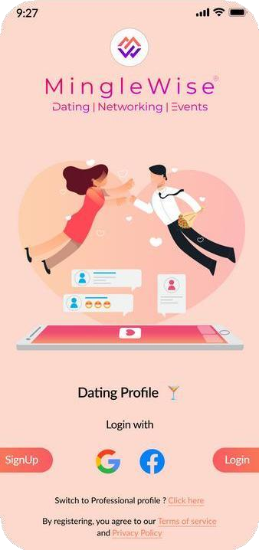

Deliverables

* **Technical Stack**
  + App: Flutter
  + Backend: Node JS,

Firebase

* + Admin Panel: Flutter
* Integrated AI for matchmaking, profile verification,

and event recommendations.

Worlds first all-in-one AI driven app for dating,

networking.



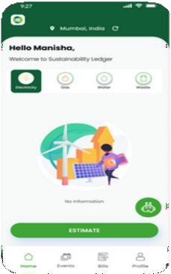

Deliverables

* **Technical Stack**
  + App: Flutter
  + Backend: Firebase
  + Admin Panel: Flutter

•

analytics, carbon tracking,

Sustainability Ledger is an app that helps household

and small business track their resource usage.

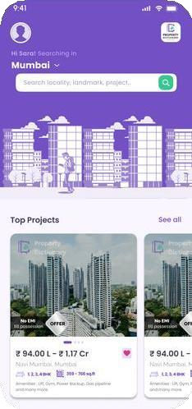

Deliverables

* Technical Stack
  + App: Flutter
  + Backend: Firebase
  + Admin Panel: Flutter
* Developed a property search app with curated listings, advanced filters, virtual tours, direct inquiries, and real-time

notifications.

Property dictionary is your go-to property dictionary

app, offering a collection of listings with comprehensive details.

 [www.appsynergies.com](http://www.appsynergies.com/)

19

CASE STUDIES



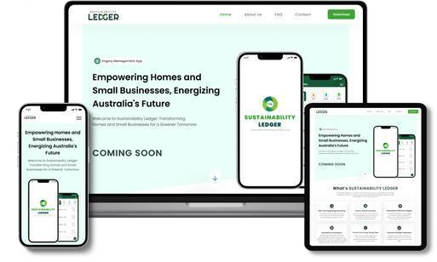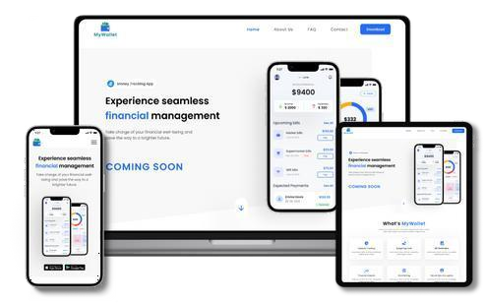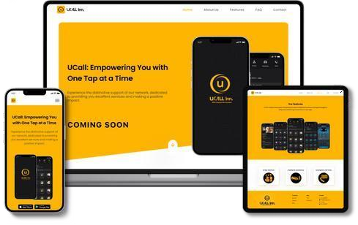

**Revolutionizing homes and small businesses for a more Sustainable tomorrow.**

* Real Time Energy Usage Monitoring
* Carbon Footprint Calculator
* Personalized Efficiency Insights
* Financial Savings Projections

**Take Control of Your Finances with Our Money Tracking App!**

* Expense Tracking
* Budget Management
* Income Analysis
* Financial Report

**Top-notch Services to users and assist in identifying the most fitting job opportunities for you.**

* + Access to Basic Services
  + Roadside Assistance Anywhere
  + Emergency Services at Your Call
  + Book any Service & get rapid response

[info@appsynergies.com](mailto:info@appsynergies.com)

+12088421478

20



 [www.appsynergies.com](http://www.appsynergies.com/)

# Contact Us

**Website** <https://appsynergies.com/>

**Phone** +12088421478

**Email** [info@appsynergies.com](mailto:info@appsynergies.com)

**Social Media**

 **Address** 186 Malvern Avenue, Harrow, HA2 9HD, UK.

D-1602, Orchid Suburbia, Link Road, Kandivali West, Mumbai 400067, India.

[info@appsynergies.com](mailto:info@appsynergies.com)

+12088421478